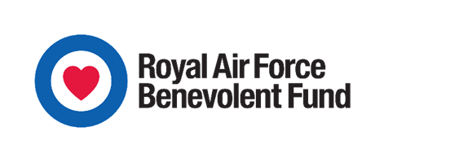

RAF BENEVOLENT FUND
APPLICATION FOR FINANCIAL ASSISTANCE – GUIDANCE NOTES

Before completing this application, it should be noted that any short-term / emergency requests of up to £750 can be made through the Minor Financial Assistance (MFA) scheme instead. This provides a quick way of ensuring that support reaches the individual who needs it, with grants normally being paid from the CO’s Fund / Community Bank which is then reimbursed to the Station by the RAFBF on submission of the MFA application.

Guidelines

The RAF Benevolent Fund can consider applications for financial assistance which should be made by completing and submitting the ‘Application for Financial Assistance for Serving Personnel’, available on the RAFBF website or on the Community Support intranet, within the RAFBF section. This document provides guidance to RAF Stations on the completion of the ‘Application for Financial Assistance for Serving Personnel’.

- All sections of the form should be completed in order to avoid delays to the process, with any not applicable sections marked as such.

- The RAFBF does not ordinarily request proof of income or expenditure to accompany Section 4, however DWP letters showing benefits being received in the household should be submitted in order that a benefits check can be carried out. Stations are asked to verify all information being provided. Section 11 requires the Station to sign to confirm this.

- With certain types of requests, supporting documentation is required. The Casework Handbook outlines these requirements; this handbook is available on the Community Support intranet, within the RAFBF section, and hard copies can also be requested from the RAFBF.

- The applicant’s statement in section 9 should contain a clear overview of what is being requested, the circumstances which have led to this and the impact the situation is having on the household. Additionally, it is helpful to see details of what, if anything, the individual has done to try to alleviate the situation, and what difference the assistance being requested would make.

- The statement within section 11 should contain a summary of the applicant’s situation from a Station perspective, and clear recommendations from the Station. The RAFBF places considerable weight on the view of the Station, and this section should be signed personally by the Station Commander or, if unavailable, OC Base Support Wing.

- We aim to consider all requests of up to £5,200 within two weeks. However, requests of over
£5,200 or which fall outside of Fund policy are considered by the Main Grants Committee which meets six-weekly. If there are particular deadlines which make the application urgent, this should be highlighted within Section 11, and we will endeavour to consider outside of committee wherever possible.

