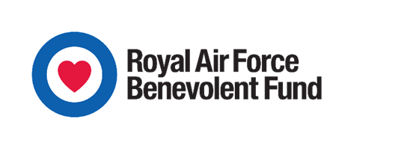

RAF BENEVOLENT FUND
MINOR FINANCIAL ASSISTANCE REQUEST (£750 OR LESS)

The Minor Financial Assistance (MFA) scheme can provide a grant of up to £750 to be used for one- off and/or emergency circumstances, without the need for a full Serving application to be submitted. Grants are normally paid by the Station from the CO’s Fund/Community Bank which is then reimbursed by the RAFBF on submission of the MFA application.

Guidelines

- This form is intended for 'one-off' and/or emergency occurrences which are expected to be short-term, e.g. emergency hospital admission resulting in travel and accommodation costs, childcare etc. and should not be used for non-priority debt issues.

- If the issue is likely to require long-term financial help the “Application for Financial Assistance for Serving Personnel” should be used. Any emergency help given by the Community Bank/CO's Fund should then be included in the application, and will be considered for reimbursement by the RAFBF.

- The RAFBF will consider all requests for minor financial assistance which we would usually expect to be submitted within three months. We will normally agree to reimburse costs of up to £750, however the RAFBF reserves the right to decline. If the request is considered to be inappropriate, feedback will be given to explain why a similar request would not be supported in the future.

- Any member of the Welfare Team can act as the Originator, but the Reviewing officer must be in the RAF, and must be someone who has access to the Community Bank/CO's Fund, i.e. either OC PMS or OC PSF, or in their absence, WO PMS or Chf Clk.

- Although this process is intended to be less intrusive than the full serving application, and does not require the disclosure of finances, both the Originating and Reviewing officers must be able to satisfy themselves that there is a genuine financial need, and supporting evidence should be obtained when possible.

- This scheme is not designed to replace statutory support that may be available. Where available and where time permits, statutory entitlements should be applied for first. If these are unable to be accessed, this should be detailed in the MFA application.

- The Acid Test: Is the situation such that you would want to put your hand in your pocket and support the individual?

